D.R.I.V.E. THE ULTIMATE DRIVING SIMULATOR, WEBSITE DESIGN DOCUMENT

# sYNOPSIS

This document will serve as a design document as it pertains to the development of the D.R.I.V.E. website. The purpose of this document is to give a broad, top-down, view of the functionality, and the look of the website. This document will include the general look and feel of the website, the color palette of the website, and some of the basic technology stack that would be needed to produce the website.

Disclaimer: This is only a prospectus, not necessarily the completed design/specification document. It is, and will be, subject to change.

# Look and feel

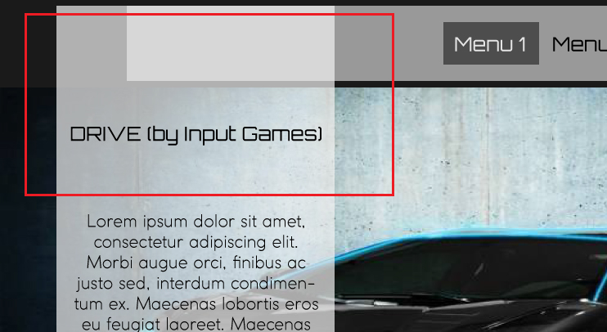The look and feel of the website is to closely resemble a sleek, futuristic, website. The various parts will be implemented in a way to be dynamic and capture the excitement of a racing title (like this game).

As such, the look will involve sharp edging as well as the use of opacity for the various explanation boxes on the screen.

The whole purpose is to give the feeling of excitement and to give the website an edgy, futuristic, look. The hope is to convey this to potential purchaser of the game in hopes that they look to purchase the title once released.

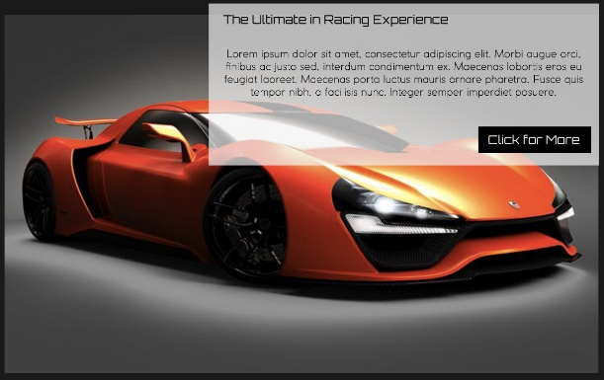Secondly, the pictures for each part of the page will be large, possibly in-game, picture of the cars either; zooming around the track, or stylish stills of the cars (preferably within a photo booth area).

Again, this is to give the feeling of excitement and to show off the amazing art-work to potential customers.

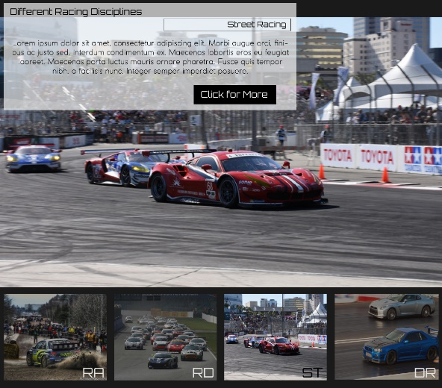This would hopefully convey the idea that game is not some cheap independent game, but an actual, perhaps on par with, a Triple-A title.

The only thing that would be needed to accomplish this is either stills or in-game captures. And it could add a lot of legitimacy to the game as a fully realized game.

The parts of the full webpage will involve a sleek landing page. The landing page will have four links at the top, and buttons within the parts of the actual landing page. All of these links will link to; Information, The Racing, Features, and in this case, Contact (which will be switched over to Purchase once the game is officially released).

The parts of the pages only give a basic synopsis, of roughly a couple of paragraphs that only gives a rough outline of some of the features of the game. These include:

## Top of the fold

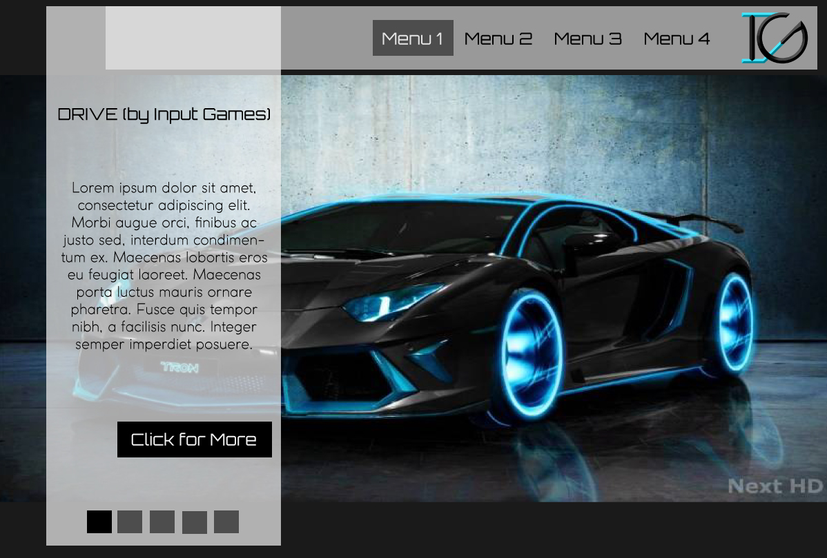The top of the page will have the top navigation (with afore mentioned links) floated over to the right side of the page. The layout is sort of flipped of what a normal webpage would look (normally, it would be from left to right), but this is on purpose to allow the info box that is floated over, and overlapping the navigation, on the left. Again, this is on purpose to play towards the sleek, futuristic, style, of the website as a whole.

Also, note the stylized carousel that will be implemented, this, again is to remove the clutter and to make the look of the website cleaner looking. Also notice the usage of opacity with the navigation and the overlapping aside. This is again for the same purposes of creating a sleek, exciting, futuristic, look to the website. This page’s button will connect the user to the Information page.

## 2nd part of the landing page

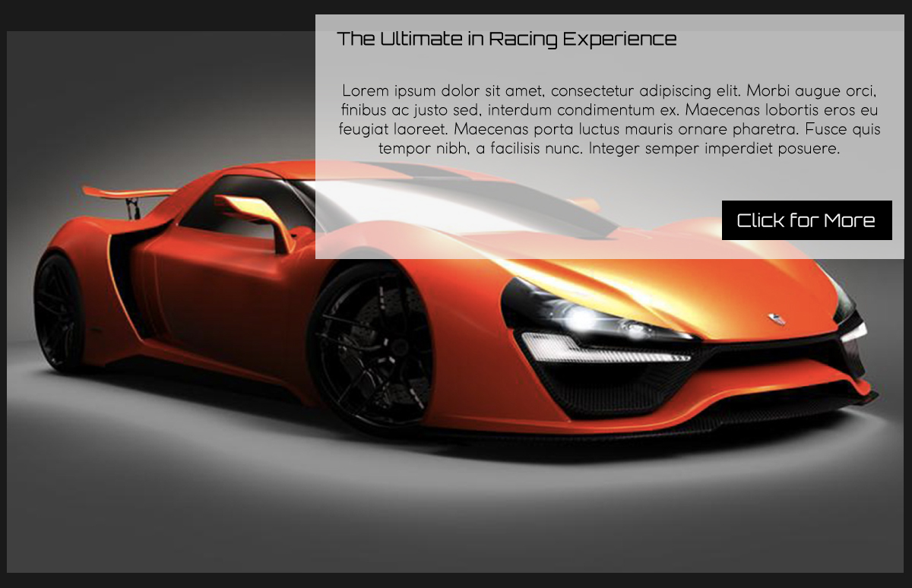The 2nd part of the landing page will follow the same design principles outlined in this document. Keeping with the general idea, all pictures will be large, banner-like, images, with sharp edges. Also notice the information block overlapping the image. This will be the same level of opacity for all blocks on this website.

The premise is to draw attention to ideas and principles of some of the features will give in a very provocative manner. The opacity is also to show that there is something there, but in the same vein not taking away from the main image being show. The button on this part of the page will connect the user to The Features page.

## 3rd Part OF THE LANDING PAGE

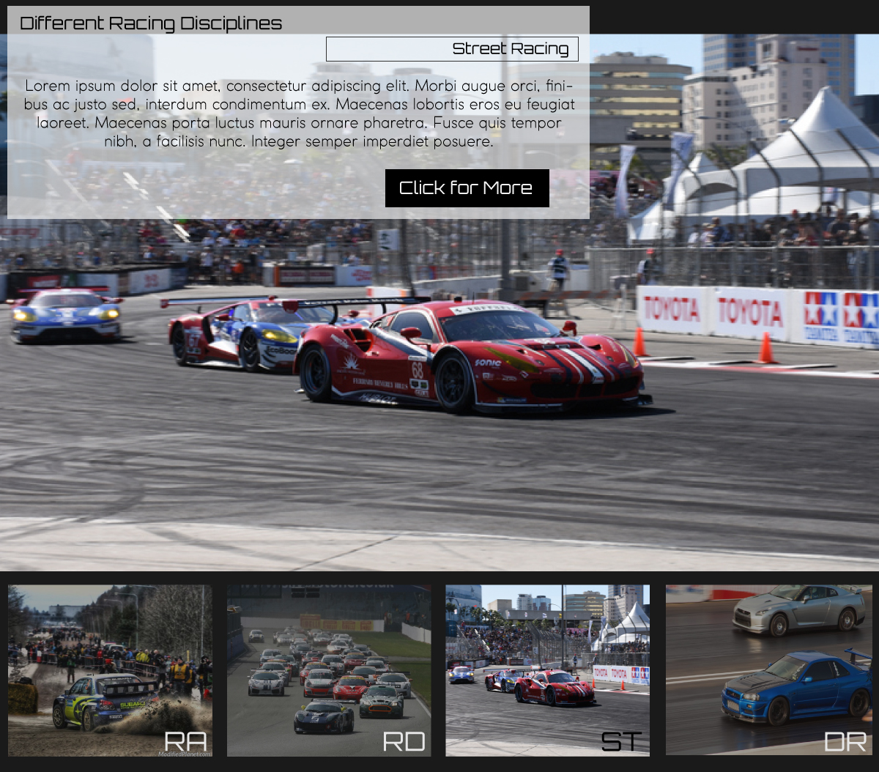Again, keeping in step with the general look and feel of the website. The main image is a large, banner-like, squared, image. This page will be linked to the Racing page. As such, the carousel will be slightly changed. As you see at the bottom of the screen, there are four, properly spaced, blocks, each representing a different form of racing that will be within the game.

Also notice that those blocks are sharp edged as well and stylized to have a two-letter initial of the type of racing; RA for Rally racing, RD for Road Racing, ST for Street Racing, and DR for Drag Racing.

Also notice that the non-selected block will be dimmed out. Again, this is to have sleek futuristic user interface. Also the information block is changed slightly. It will be four parts; the title, the information, button, but in between the title and information parts, will be a stylized bordered block, this will have the spelled out word of the two-letter initials. Again, this is to match the style of the website. Also this page’s button will go to The Racing part of the website.

## Bottom part and site-map

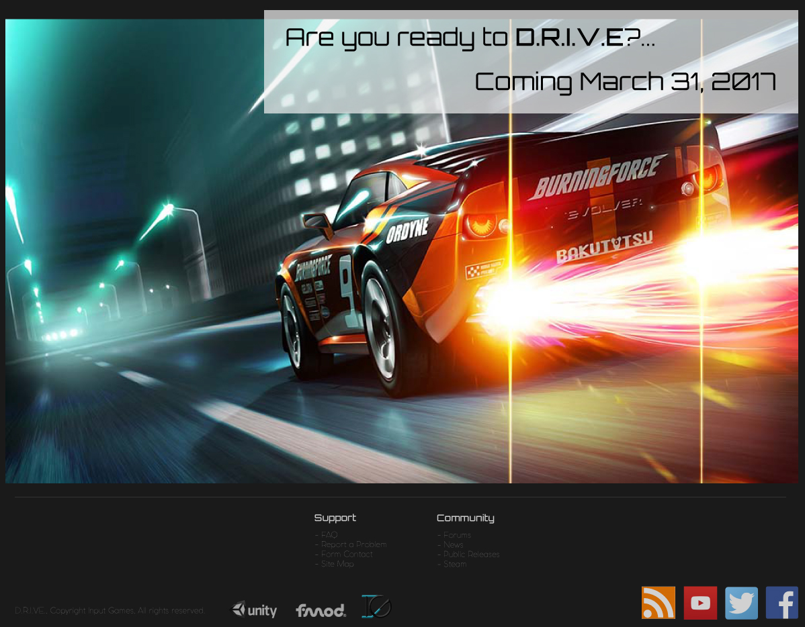The bottom part of the page will change dependent upon when the actual release of the game is, but the general look will not change. As always, the main image will be a large, banner-like, sharped-bordered, image. Also it will have the same offset information block (it will flow from left, right, left, and right on this part), again with just enough opacity to tell the user that there is something there, but not too little that it blocks out the main image.

Also, to match the sleekness of the website, the only separation from the image to the site-map portion will be a simple, effective, horizontal line. Because this site is rather simplistic in design, it should also be so in site-map design. As opposed to flooding the user with a litany of links to various parts of the website, it will only have two parts; Support and Community, with only important sub-links. This is done for simplicity and to only give the user what the user needs and to avoid cluttering up the site-map portion of the page.

Below that is a simple band that shows; copyright information, logo icons of the software used for the game, and finally any social media links.

# colors and fonts

## colors

Due to the overall, general, style, mentioned above about the look of the website, it will use a dark color pallet. The reason is that to have a sleek, futuristic, feel, to the website, it would be difficult to do so while using a lighter, brighter, color pallet.

As such, the color pallet will include variations of the Monochromatic spectrum of black:



Also, any normal colors that might be used will be varying, Monochromatic spectrum of dark blue:

This, again, is to keep the look and style sleek. This is also to keep with the ideas of keeping the look simple. Also, by avoiding using multiple colors, we avoid distracting the user with various, and relatively odd, color combinations.

As shown in the stills, because any text will be placed in front of a white background box, there would be little need to change the color. Therefore, the text color would be either an; off-white, or off-black.



## Text

Keeping in the theme of the site. All the text will be of a sans-serif font and will also be stylized in a way that should convey a sleek, edgy, and futuristic, look. Also, because of the fact that the website’s, and company, funding. The fonts should be free to use or have a license that would allow for it to be used in the webpage. Because of this, the fonts will be drawn from Google Fonts list of fonts.

As such, the two main fonts that will be used is Orbitron and Saira.

(Orbitron example)

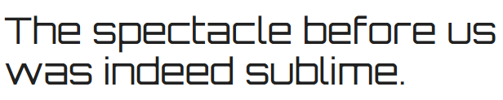

(Saria example)

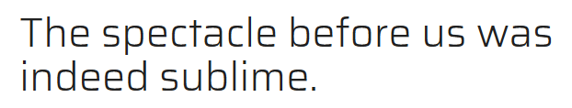

Because of the look and style of the pages, there would be little need to go beyond Regular for both fonts. So the hierarchy would go:

* Regular Font (for Headers and important information)
* Light Font (for all other parts of the page)

# tECHNOLOGY STACK

## oVERALL

Because of the fact that this would be a rather client-heavy website, the need to include such technologies for back-end/server-side would be rather diminished. As such, the technology stack would be rather front-end heavy (with very little needed to call from the back-end).

Because of cost concerns, this pretty much disqualifies a Microsoft stack, and would therefore have to have front-end technologies, backed up with PHP. This should allow for an easier, more cost effective manner, of developing and implementing the website online. Depending on needs, if certain functionality is needed (certain community features, for example), Wordpress would be a good choice. But with that comes added, and in some cases, unnecessary, complications. This might impede the development of the website, also certain features for responsiveness and functionality could be compromised.

So, after careful consideration, Wordpress will be ignored for a simpler method to include:

* HTML
* CSS
* SCSS/SASS
* Javascript
* JQuery
* Twitter Bootstrap
* PHP

The Discussion Boards can easily be linked to a public one online. All forms (Issues, Feedback, etc.) could easily not require anything special. And all News pages could easily be done through simple HTML with PHP call backs to the database. This also alleviates the need for AJAX/Asynchronous programming.

Twitter Bootstrap and CSS pre-processor usage would allow for easier to maintain, and quicker turn around, for a website that is responsive pretty much right out of the box. And Javascript and JQuery should be more than enough to provide extra features/functionality to the website.

# In closing

In closing, the purpose of this document was to explain what would be the general look and feel of the website. Under no circumstances were the functionality or specifications meant to be taken literally in this document. This was to merely be a general, top-down, prospectus of what the website will look like in this configuration. If any changes are to be required, then this document will be updated, and/or changed.

Regardless, this document went into detail of; how the site will look like in this configuration, descriptions of what the site should express to the user, the general feel the site should give, the colors used, and the fonts needed, for the development of this website. Also included was an idea for the technology stack needed for the development, and implementation, of the website. All with the expressed concern as to notify what the current design for this website will be. This has been accomplished via the completion of this document.

D.R.I.V.E. THE ULTIMATE DRIVING SIMULATOR, WEBSITE DESIGN DOCUMENT

*Copyright © 2016, property of Input Games and Paul Laudun*